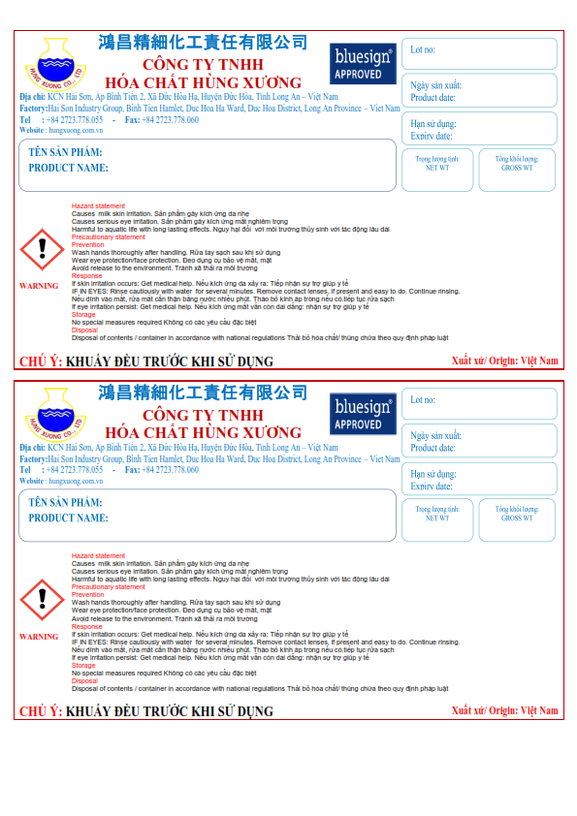

**KG**

**KG**

**HUNTEX DI-01**

**HUNTEX DI-01**

**HUNTEX DI-01**

**HUNTEX DI-01**

**KG**

**KG**

**HUNTEX DI-01**

**HUNTEX DI-01**

**HUNTEX DI-01**

**HUNTEX DI-01**